File Folder Activities
Leaders
Essential Visuals for students’
http://blog.maketaketeach.com/fall-themed-file-folder-activities-2/
Fall word match
Winter word match
Spring word match
Summer word match
Get dressed with me activity – rainy day, snow, work in the garden
Rhyme Match (acorn) Word and Picture match
Sound Match Alphabet match
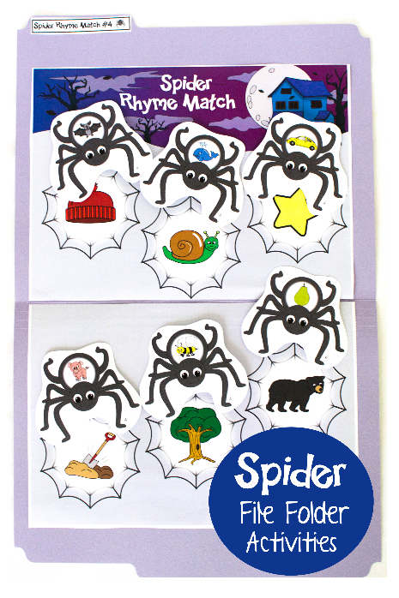
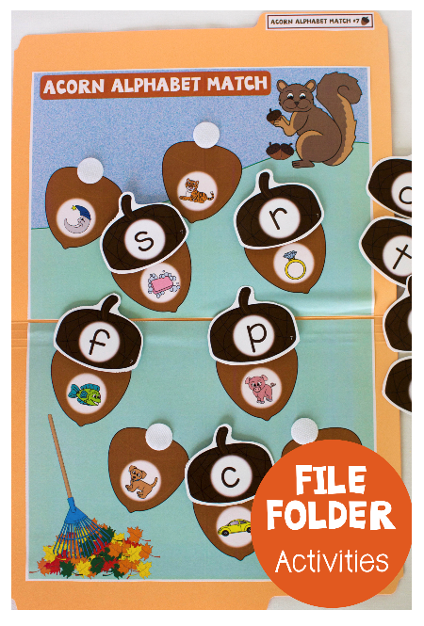
http://blog.maketaketeach.com/fall-themed-file-folder-activities-2/

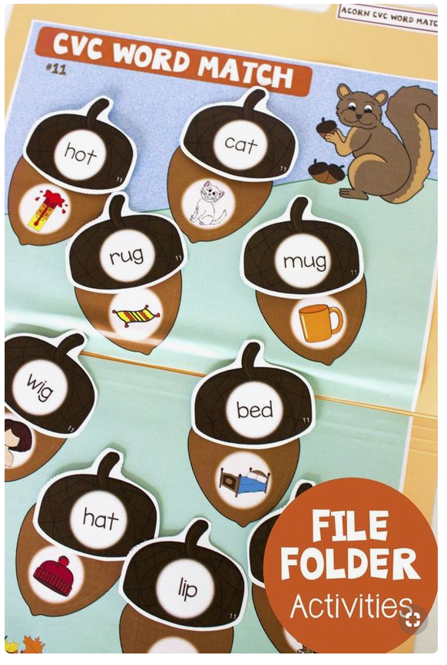

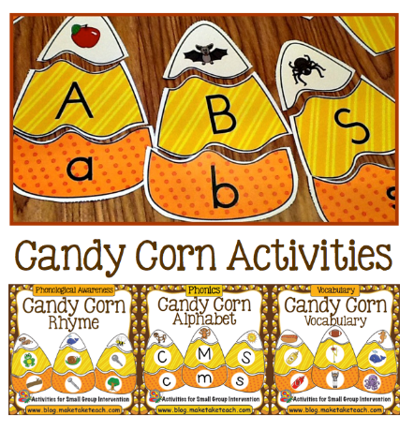

http://blog.maketaketeach.com/candy-corn-activities-2/

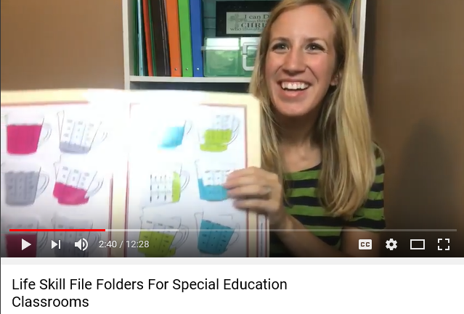
https://youtu.be/WHnzp3_o2Gc

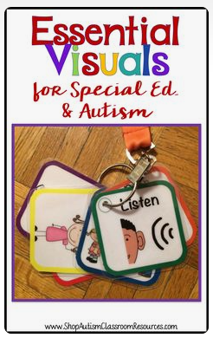
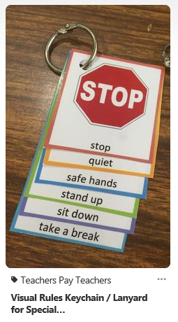
More freebies: http://blog.maketaketeach.com/wp-content/uploads/2016/10/Spider-Addition.pdf

